Hello!
I am Personal Publishing Consultant and looking to expand my business.
To do so I need a photographer and a wedding planner to join forces with them and offer high quality products and services to our clients.
Below is a description of what I have to offer.
The products I offer satisfy every publishing need and can be used for various purposes.
I have books whose sizes range from 5x5 to 13x11 and then posters, canvases, cards, playing cards, calendars and more.
I am including a sample of some of them, but it really needs to be seen in person to fully appreciate the value, quality and versatility of them.
The books are hard bound, stitch bindings with acid free full bleed pages, and the Legacy 13x11 book comes with leather cover and paper jacket, and is perfect as a wedding album.
The small 5x5 and or 5x7 books can be used as a table center piece and have engagement pictures with a little story of the bride and groom, and be perfect gifts for the wedding party.
The 8x8 and the 8.5 x11 are perfect as a signature book, containing pages with the engagement pictures and space for the guests to sign or leave a thought.
For invitations, save the date, thank yous, we have gorgeous 5x7 folded cards, postcards, invitations, 3,5,7 panels family folds and a completely customizable deck of playing cards that are sure to impress your clients.
Posters and canvases are perfect to display favorite wedding pictures.
The only limit is really your imagination and creativity.
Please take a look at the samples below and I am sure you will want to know more!
Just click on the view this project button and enjoy!^_^
 | FROM: Michelina Hall    Project Name: Love  Author: Michelina Hall  Project Type: 5 Panel Family Fold

If the "View This Project" button doesn't work, copy-and-paste this link into your browser:
http://www.heritagemakers.com?event=projectBrowse&projectId=849e78ab-3048-34f0-e24d-99a49dd39688&productId=55&projectSponsor=236440
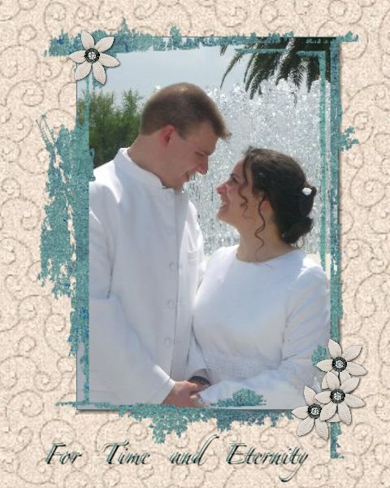 | FROM: Michelina Hall  Project Name: For Time and Eternity  Author: Michelina Hall  Project Type: 7.5x10 Storybook
If the "View This Project" button doesn't work, copy-and-paste this link into your browser:
http://www.heritagemakers.com?event=projectBrowse&projectId=a129b0ff-3048-322b-c0ee-6a5c002af43e&productId=7&projectSponsor=236440
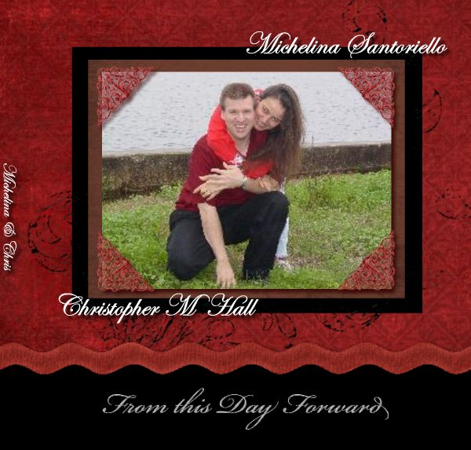 | FROM: Michelina Hall  Project Name: ChrisandMichelina signature book  Author: Michelina Hall  Project Type: 8x8 Storybook
If the "View This Project" button doesn't work, copy-and-paste this link into your browser:
http://www.heritagemakers.com?event=projectBrowse&projectId=566b8b79-f1e7-435c-9203-655f1bb55fe8&productId=5&projectSponsor=236440
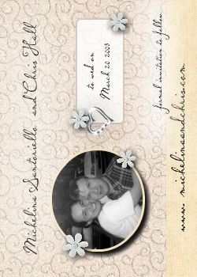 | FROM: Michelina Hall  Project Name: wedding ideas  Author: Michelina Hall  Project Type: Playing Card Deck
If the "View This Project" button doesn't work, copy-and-paste this link into your browser:
http://www.heritagemakers.com?event=projectBrowse&projectId=d288d29b-f2be-4c40-898d-d201ce3ec8a1&productId=63&projectSponsor=0
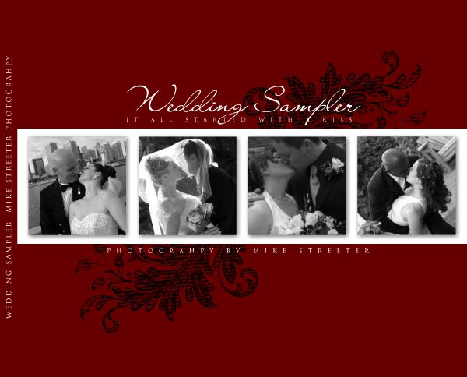 | FROM: Michelina Hall  Project Name: Classic Red Photographers Album  Author: Wenda Top  Project Type: 13x11 Legacy Edition Storybook

If the "View This Project" button doesn't work, copy-and-paste this link into your browser:
http://www.heritagemakers.com?event=projectBrowse&projectId=3bb82b2f-acbb-4199-b3a6-466c06bf36e7&productId=59&projectSponsor=236440
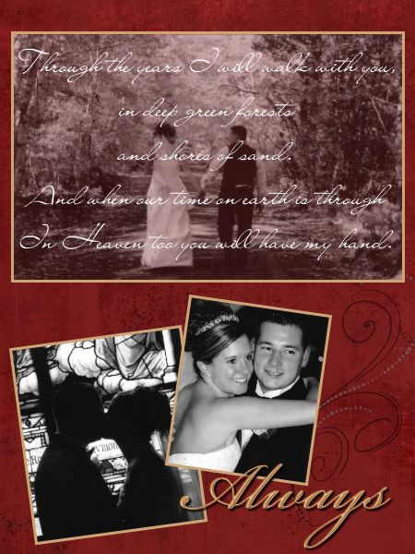 | FROM: Michelina Hall  Project Name: wedding poster updated  Author: Stacey Corrigan  Project Type: 18x24 Portrait Poster
If the "View This Project" button doesn't work, copy-and-paste this link into your browser:
http://www.heritagemakers.com?event=projectBrowse&projectId=9b403beb-e4e1-4490-bd11-ae0ed6c81ec8&productId=27&projectSponsor=236440
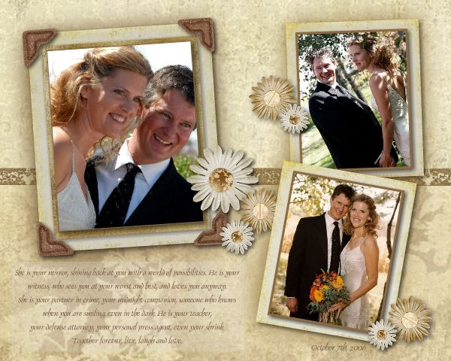 | FROM: Michelina Hall  Project Name: Wedding Canvas  Author: Julie Riesgraf  Project Type: 20x16 Canvas Poster
If the "View This Project" button doesn't work, copy-and-paste this link into your browser:
http://www.heritagemakers.com?event=projectBrowse&projectId=fec1ff8c-c68b-4b7d-9865-bf8b75c122fc&productId=58&projectSponsor=236440
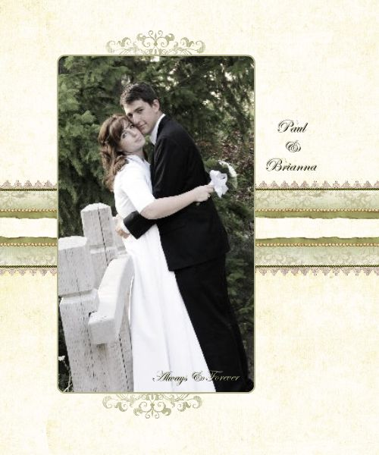 | FROM: Michelina Hall  Project Name: Forever You  Author: Dixie Burt  Project Type: 20x24 Gallery Wrapped Canvas
If the "View This Project" button doesn't work, copy-and-paste this link into your browser:
http://www.heritagemakers.com?event=projectBrowse&projectId=8a463846-3048-322b-c0e6-3a892b2b08af&productId=72&projectSponsor=236440
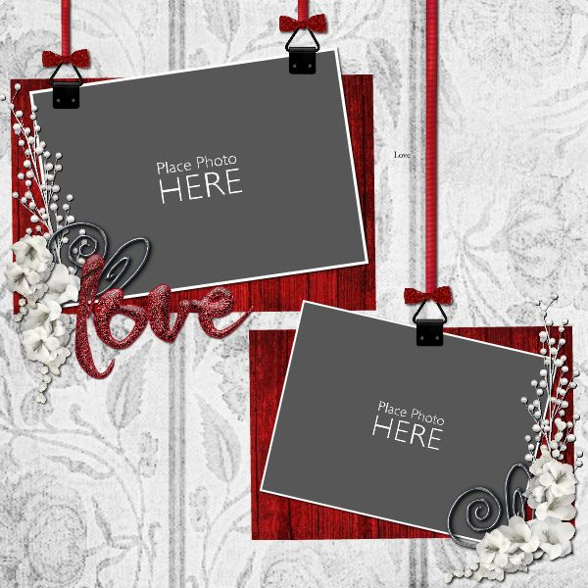 | FROM: Michelina Hall  Project Name: Love Template  Author: Michelle Wolfley  Project Type: 12x12 Scrapbook Page
If the "View This Project" button doesn't work, copy-and-paste this link into your browser:
http://www.heritagemakers.com?event=projectBrowse&projectId=3ccbb2c0-3048-6168-a6d7-bc1f0a7db836&productId=64&projectSponsor=236440
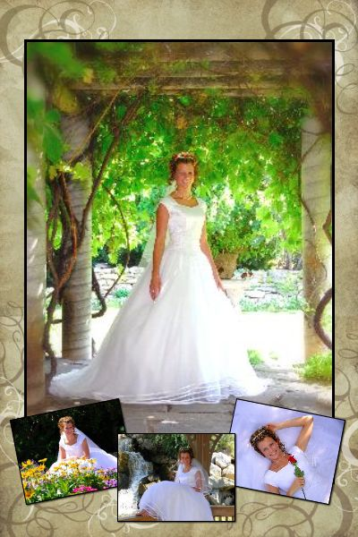 | FROM: Michelina Hall  Project Name: Bridal Poster 12x18  Author: Debie Adams  Project Type: 12x18 Portrait Poster
If the "View This Project" button doesn't work, copy-and-paste this link into your browser:
http://www.heritagemakers.com?event=projectBrowse&projectId=eacab5aa-5167-4d56-8f30-0557c34b6a80&productId=23&projectSponsor=236440
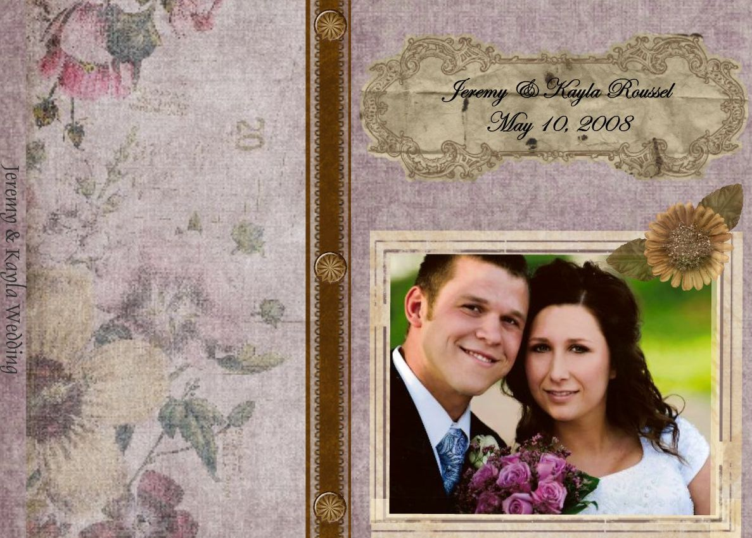 | FROM: Michelina Hall  Project Name: Kay and Jay  Author: Monya Williams  Project Type: 11.5x8.5 Storybook
If the "View This Project" button doesn't work, copy-and-paste this link into your browser:
http://www.heritagemakers.com?event=projectBrowse&projectId=3f4fec25-3048-322b-c078-7adbfeebc500&productId=9&projectSponsor=236440
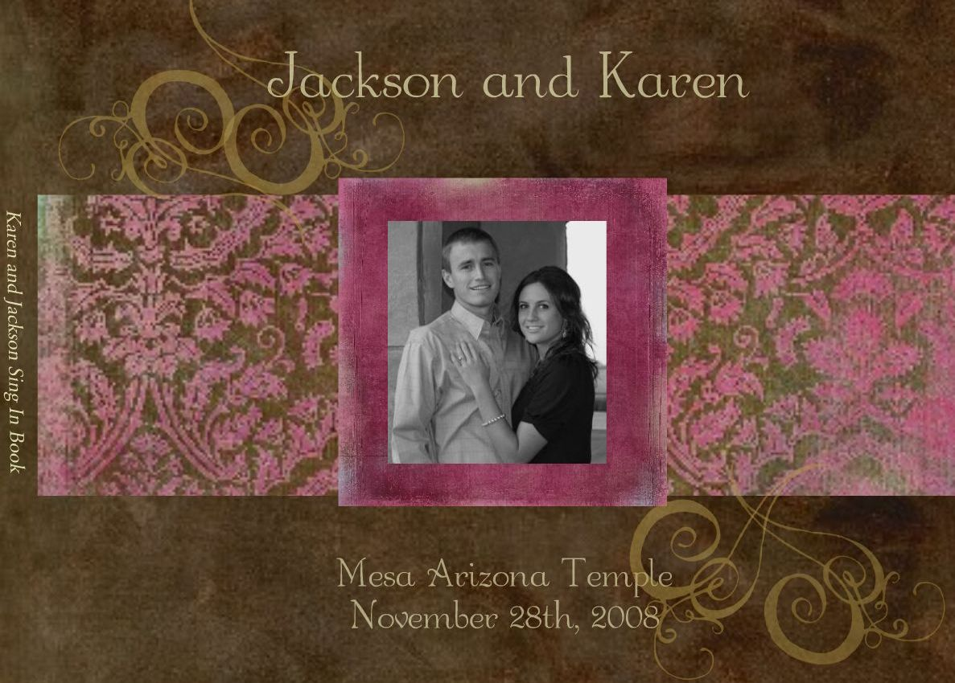 | FROM: Michelina Hall  Project Name: karen and jackson  Author: Monya Williams  Project Type: 11.5x8.5 Storybook
If the "View This Project" button doesn't work, copy-and-paste this link into your browser:
http://www.heritagemakers.com?event=projectBrowse&projectId=401f7413-3048-322b-c022-95b34358762a&productId=9&projectSponsor=236440
 | FROM: Michelina Hall  Project Name: Wedding Thank You Cards  Author: Erin Long-Breininger  Project Type: 5x7 Invitation: Landscape
If the "View This Project" button doesn't work, copy-and-paste this link into your browser:
http://www.heritagemakers.com?event=projectBrowse&projectId=8c204753-5840-4402-bf90-76c44e04b251&productId=68&projectSponsor=236440
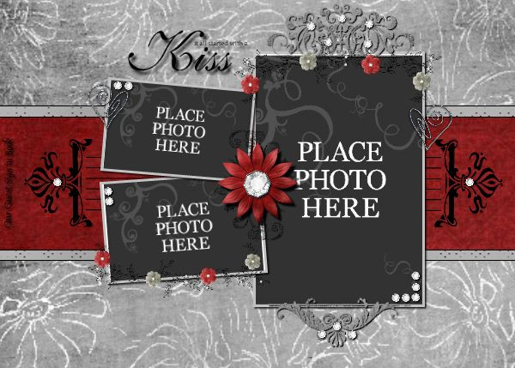 | FROM: Michelina Hall  Project Name: Royal Elegance wedding book  Author: HM Exclusive Templates  Project Type: 11.5x8.5 Storybook
If the "View This Project" button doesn't work, copy-and-paste this link into your browser:
http://www.heritagemakers.com?event=projectBrowse&projectId=6d50f725-5fb5-4f99-9cb0-576faf4fd961&productId=9&projectSponsor=236440
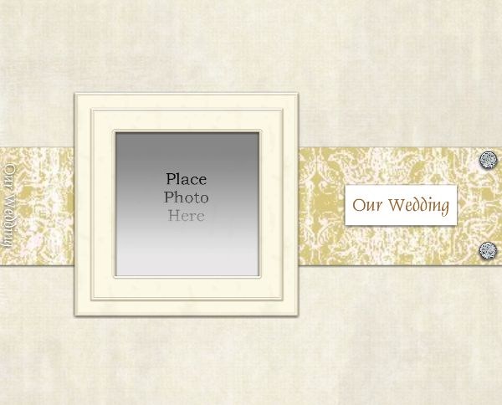 | FROM: Michelina Hall  Project Name: A Wedding Story - Ivory  Author: Darcie Toom  Project Type: 13x11 Legacy Edition Storybook
If the "View This Project" button doesn't work, copy-and-paste this link into your browser:
http://www.heritagemakers.com?event=projectBrowse&projectId=8d09446d-293e-41cb-b439-825958df8642&productId=59&projectSponsor=236440
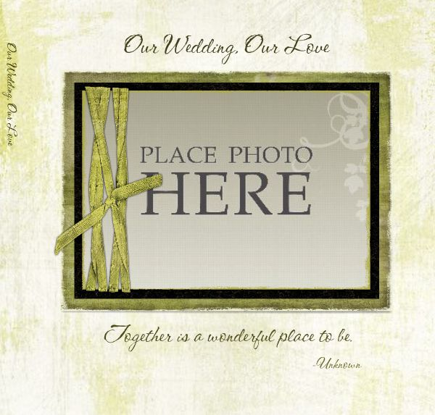 | FROM: Michelina Hall  Project Name: Our Wedding, Our Love  Author: Dixie Burt  Project Type: 8x8 Storybook
If the "View This Project" button doesn't work, copy-and-paste this link into your browser:
http://www.heritagemakers.com?event=projectBrowse&projectId=99f0c629-6a2d-459f-a596-e3b17298a375&productId=5&projectSponsor=236440
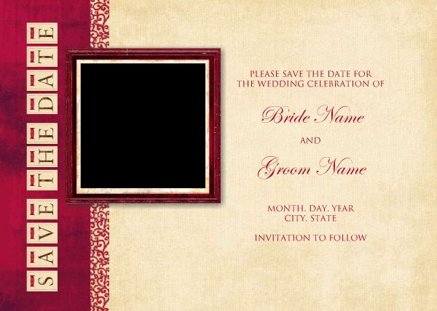 | FROM: Michelina Hall  Project Name: TMP: WED-Save the Date, Love2 7x5  Author: Jenita Varela  Project Type: 5x7 Post Card: Landscape
If the "View This Project" button doesn't work, copy-and-paste this link into your browser:
http://www.heritagemakers.com?event=projectBrowse&projectId=5583f85a-3048-6168-a682-7e3bf53f5d88&productId=20&projectSponsor=236440
 | FROM: Michelina Hall  Project Name: Wedding Guest Signature Book  Author: Debie Adams  Project Type: 11.5x8.5 Storybook
If the "View This Project" button doesn't work, copy-and-paste this link into your browser:
http://www.heritagemakers.com?event=projectBrowse&projectId=24c4caab-22d5-42ff-ac96-773609371aad&productId=9&projectSponsor=236440
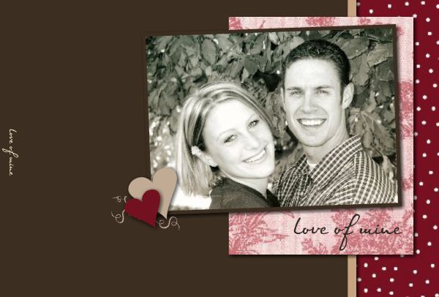 | FROM: Michelina Hall  Project Name: Love in the Air  Author: Michelle Bell  Project Type: 7x5 Storybook
If the "View This Project" button doesn't work, copy-and-paste this link into your browser:
http://www.heritagemakers.com?event=projectBrowse&projectId=06240cd3-9fe9-43cb-9bba-783b44a61e08&productId=3&projectSponsor=236440
-- Thank you,
Michelina Hall
(904) 287-7543

info@preservemyheritage.com

Visit me in the web: www.preservemyheritage.com

Click here if you want to save your pictures from those boxes in the closet.
CLICK HERE to see why my product is one of Oprah's ALL-TIME favorite gifts!!

Connect to your Italian Heritage www.CavaGenealogy.com
--
Michelina Hall
(904) 287-7543
Visit me in the web: www.preservemyheritage.com
Click here if you want to save your precious pictures from possible damage or loss.
CLICK HERE to see why my product is one of Oprah's ALL-TIME favorite gifts!!

